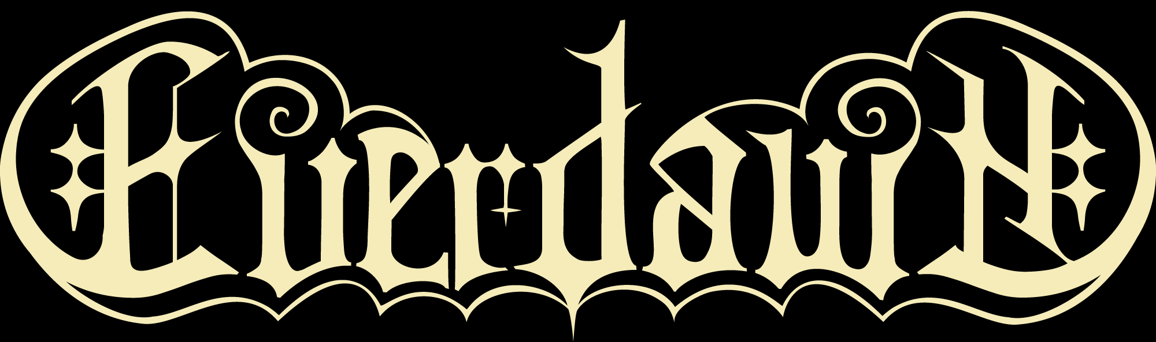

EVERDAWN is a female fronted symphonic metal band based out of New Jersey. The band was originally created in March 2014 under the moniker Midnight Eternal, counting founding members, Boris Zaks, Richard Fischer, Dan Prestup and Mike LePond (Symphony X).
In early 2016 the band signed a management deal with Intromental Management and released their self-titled debut album (Marquee/Inner Wound). The album was engineered by Eric Rachel (Skid Row, Symphony X) and the mixing and mastering was handled by Tommy Hansen (Helloween, Pretty Maids, Jorn). The impressive artwork was created by Jan Yrlund (Apocalyptica, Korpiklaani, Delain).

The band commenced on a North American tour, as support of the amazing prog-veterans Queensryche and toured Europe as support for the avantgarde-kings of Therion – 2 amazing and lengthy tours that took the band to another level. It was suddenly a name to be reckoned with, even after only one album.

After a few changes in the line-up and the inclusion of the amazing voice of the young and very talented Russian born, Canadian singer Alina Gavrilenko, who brought a full-blown energetic vocal approach into the new songs of the band, the name was changed into EVERDAWN, to signal a fresh beginning.

In the spring of 2020, EVERDAWN inked a worldwide deal with the US-based record label Sensory, who was blown away by the high-level performance of the band. For the release of the 2nd album of the New Jersians.

The album, entitled ”Cleopatra”, which was released worldwide on March 5th, 2021 was recorded during the summer of 2019 and was mixed and mastered by Dan Swanö, well-known for his work, both as a musician and as producer (Opeth, Evergrey, Omnium Gatherum, a.o.) and dives even further into the melodic furnace, where hits are created.

The stunning artwork for the new album was created by the uber-talented Hungarian artist Gyula Havancsák (Annihilator, Grave Digger, Tyr, a.o.) and displays a breathtakingly beautiful version of the old Egyptian queen and the surroundings in her temples and lands. A must-have for collectors!

After the release of “Cleopatra”, a replacement had to be found for LePond. The replacement was the local bass player, Alan D’Angelo and the 5-piece went on a sold-out European tour, as sole support band for worldwide acclaimed guitar virtuoso Michael Schenker, while also writing their new opus “Venera”, which was recorded, mixed and mastered during the fall of 2022 (Jacob Hansen @ Hansen studios took care of working magic with the sound as he has done with so many bands, a.o. Volbeat, Amaranthe, Destruction, Pretty Maids).

The album caught the attention of the Italian record label Frontiers records, and EVERDAWN found a new long-term home, striving for World-acclamation. “Venera” was released in December 2023 to worldwide acclaim by the press and fans as well, and the band is now being booked for shows both in Europe and North America.

The melodic style of the band is unmistakable and with soaring guitar soli, and a truly unique voice, EVERDAWN is proving that they are a band to be reckoned with.

Line-up:
Alina Gavrilenko - vocals
Richard Fischer - guitars
Alan D’Angelo - bass
Dan Prestup - drums
Boris Zaks – keyboards

