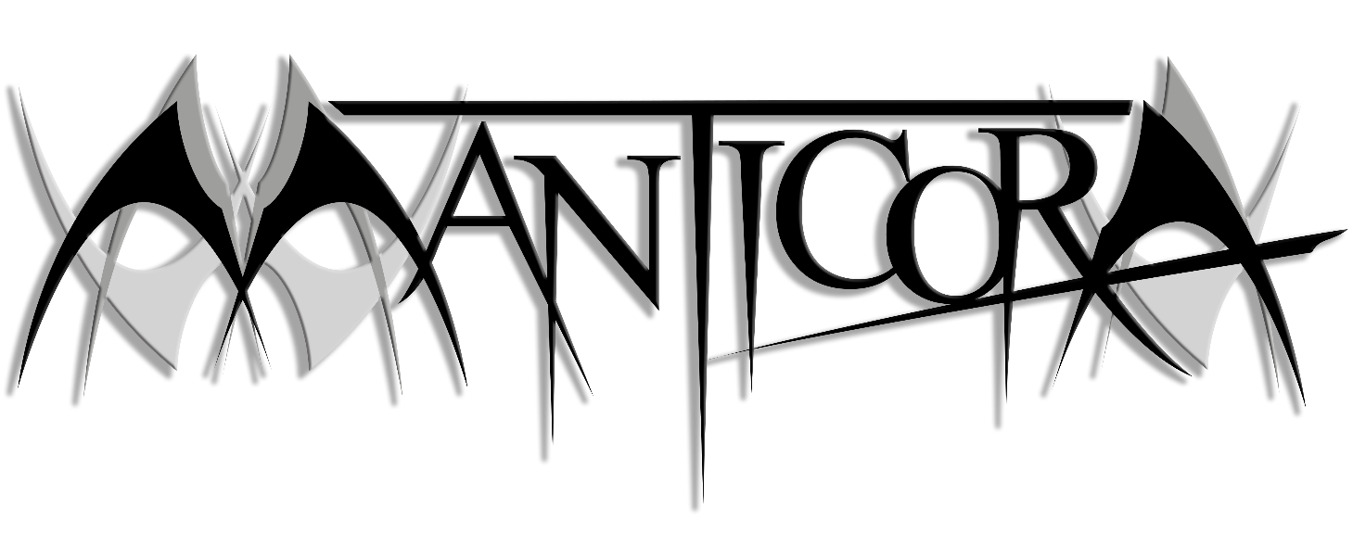MANTICORA Bio 2023

MANTICORA was formed in 1997 by Lars F. Larsen (vocals), Kristian Larsen (guitars) and Mads Volf (drums). In the early days the band was a foursome with bass player Rene as the last member – the young guys laying the foundation of the MANTICORA-trademark sound; hard hitting progressive power metal with both epic and thrash elements.

In 1998 MANTICORA signed with Intromental Management and shortly afterwards their first record deal was signed with Greek record label Black Lotus. The same year the band added an extra guitarist, and a keyboardist, to the line-up. The debut full-length disc, “Roots Of Eternity”, was released in summer 1999, and received tremendously good response from both media and fans around the world.

2000 saw the band signing with Scarlet Records, and half a year later the next opus, “Darkness With Tales To Tell”, was released, once again receiving great acclaim. In 2001 bassist Rene decided to leave the band and the vacancy was filled by Kasper Gram as the new bass pounder. Also the guitar spot was changed, as Flemming left MANTICORA and Martin Arendal joined the band.

In the fall 2002 “Hyperion” was released. This was the so-far most wide-spanning work of the band; an epic concept album, based on the award-winning sci-fi novel “Hyperion” by Dan Simmons. The album was whole-heartedly embraced by fans and media worldwide, and with a European tour in the spring 2003 MANTICORA took another step up the ladder.

In early 2004 the band began working on and releasing their next disc, “8 Deadly Sins”, yet another conceptual one. The album was recorded in Jailhouse Studios with producer Tommy Hansen (Helloween, Pretty Maids, etc.). In February 2005 the band toured throughout Europe together with Angra and Edenbridge. The band then did their first ever (highly successful) US appearance at the ProgPower Festival in Atlanta, GA.

The band once again went into studio in 2006, to record their 5th full-length album, the first part of the 2-album concept “The Black Circus”. Once again produced by Tommy Hansen, the album was bigger, better and more adventurous than ever before. After a mini-European tour, alongside Andromeda, MANTICORA hit Jailhouse Studio to finalize the 2nd part of “The Black Circus”. With the new album in their now extended catalogue, MANTICORA went on both European and USA tours, as support for Jon Oliva’s Pain, and another tour was booked for Europe in May 2009, as support act for Circle II Circle. This time, going through 16 countries for 21 shows.

In 2010 MANTICORA’s 7th full length album was released worldwide. “Safe” was an even darker journey in the musical universe of MANTICORA. A European headliner tour was booked for October 2010, taking the band through nine different countries.

In August 2012, MANTICORA finally performed at the world’s largest metal festival – Wacken Open Air, and it led to the band, re-opening the goodie-bag of writing new material. April 2013, saw the band, playing the prestigious PPM festival in Belgium, and a month later, Martin played his last show with MANTICORA. Stefan Johansson – who appeared as session musician on the 2005 Angra tour, was enrolled as a new guitarist.

After another European headliner tour in 2014, Mads decided to leave the drum-throne, to pursue other musical endeavors, and MANTICORA spent 4 years, writing a grandiose double concept album, based on the 334 pages novel, that lead singer Lars wrote in the meantime.

In august 2018, MANTICORA released their so far most ambitious work, the 8th full length album ”To Kill To Live To Kill”, produced by Jacob Hansen to secure an aggressive and modern sound. The band's 334 pages horror novel was released at the same time.

2018 and 2019 were spent, touring the world (Europe, North America, Japan) and saw the band appearing for the first time ever in countries, like Canada, Japan, Mexico and Norway. Manticora played a load of festivals - among them, Wacken Open Air, Copenhell and Evoken Fest in Japan.

The drums on the last two albums were recorded by the Swedish drum-wizz Lawrence Dinamarca, who has brought an immense amount of technical aspects into the music of MANTICORA.

MANTICORA released the second part of the grandiose concept, this one entitled ”To Live To Kill To Live” on August 28th 2020, as a perfect follow-up to the 2018 album. The horror story was concluded and once again, Jacob Hansen worked wonders on the production, as well as David Troest, creating a stunning piece of artwork for the album and the whole booklet. A European tour was booked for the spring of 2021, but pandemic struck, and the tour was pushed to May/June 2022, where Europe once again felt the full effect of a live-Manticorization.

With a year of writing, tuning and concept-developing, the band is ready to record their 10th album and is also signing a record deal with the Danish label Mighty Music about the release. MANTICORA is returning to their home country.

Line-up:
Kristian Larsen - guitars
Lars F. Larsen - vocals
Stefan Johansson - guitars
Kasper Gram - bass
Lawrence Dinamarca - drums

Discography:
Roots Of Eternity (1999)
Darkness With Tales To Tell (2001)
Hyperion (2002)
8 Deadly Sins (2004)
The Black Circus - part 1 (2006)
The Black Circus - part 2 (2007)
Safe (2010)
To Kill To Live To Kill (2018)
To Live To Kill To Live (2020)
TBA – (2023)
Bibliography:
To Kill To Live To Kill (2018)
Manticora online:
www.manticora.dk
www.facebook.com/manticoraband
www.instagram.com/manticoraband
Manticora Video links:
"Echoes Of A Silent Scream" (2018 video from the album "To Kill To Live To Kill")
https://www.youtube.com/watch?v=YhqZtxtqAoQ&list=RDYhqZtxtqAoQ&start_radio=1
"Eaten By The Beasts” (2020 video from the album "To Live To Kill To Live")
https://youtu.be/Nrpm_xoPyIc
Manticora Labels:
Mighty Music
Manticora Publishing:
Enorm Music GmbH / Target Group
Manticora Endorsements:
Engl Amplifiers - Sandberg Strings - Evans Drumheads - Pro-Mark Sticks – Meinl Cymbals – Solar Guitars

